DEPENDENT AND INDEPENDENT EVENTS
Independent events
Independent events are two events whereby the outcome of one event does not affect the outcome of the other event. A good example independent event is rolling dice and tossing a coin. The occurrence of both events does not affect each other.
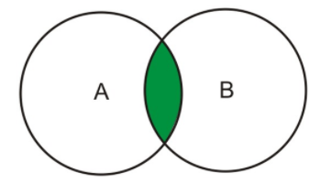
The probability of both of these events occurring is the product of each event i.e. $P\left(A and B\right)=P\left(A\right)*P(B)$
EXAMPLE 1
What is the probability of picking either a spade or face card from a standard deck of cards?
Solution
A standard deck of cards has 52 cards.
There are 13 spades and 12 face cards. Out of the 12 face cards, there are 4 spades
$$P\left(A or B\right)=P\left(A\right)+P\left(B\right)-P\left(A and B\right)=\frac{13}{52}+\frac{12}{52}-\frac{3}{52}=\frac{22}{52}=\frac{11}{26}$$
Dependent events
Two events are dependents on when the outcome of one event affects the outcome of the second event. An example of a dependent event is drawing a red marble from a bag and drawing a blue marble in the same bag without replacement. The probability of both events is $P\left(A and B\right)=P\left(A\right)*P(B|A)$ where $P\left(B | A\right)$ is the probability of B occurring given that A has occurred.
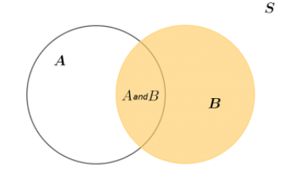

EXAMPLE
You have 17 marbles in a bag. 6 marbles are red while the rest is black. What is the probability of picking a red marble two twice in a row without replacement?
Solution
$$P\left(red\right){\left.​\right|}_{1st time}=\frac{6}{17}$$
$$P\left(red\right){\left.​\right|}_{2nd time}=\frac{5}{16}$$
$$P\left(red\right)=\frac{6}{17}*\frac{5}{16}=\frac{15}{136}≈0.1103$$

MUTUALLY EXCLUSIVE/DISJOINT EVENTS
Mutually exclusive/disjoint events are two events that cannot occur at the same time. For example, tossing a coin and obtaining heads and tails. You can only obtain head or tails but not both at the same time. Another example is turning left and turning right when walking. You can only turn in one direction at a time. The probability of obtaining event A or B is $P\left(A or B\right)=P\left(A\right)+P(B)$. The probability of obtaining events A and B is always 0.
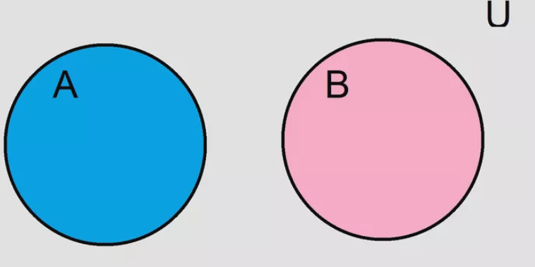
EXAMPLE
Find the probability of rolling a fair dice and obtaining a 4 or an odd number.
Solution
$$P\left(4\right)=\frac{1}{6}$$
$$P\left(even number\right)=\frac{3}{6}=\frac{1}{2}$$
$$P\left(4 or even number\right)=\frac{1}{6}*\frac{1}{2}=\frac{1}{12}$$
Non-mutually exclusive events are events that can occur simultaneously. An example is rolling dice and obtaining prime numbers and even numbers. The probability of obtaining event A or B is $P\left(A or B\right)=P\left(A\right)+P\left(B\right)-P(A and B)$.
